Curriculum Vitae

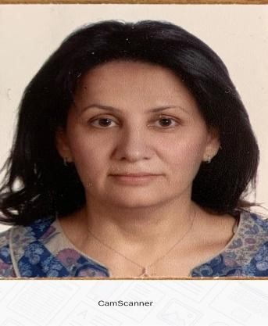

• Name: Sanaa Youssef Ibrahim Majdalawieh
• Nationality: Jordanian
• Place of Birth: Amman, Jordan
• Current Position: Instructor in the Department of Curriculum and Instruction at School Of Educational Sciences , University of Jordan.
• Phone: 5355000 ext. 24507
• Mobile: 0796799266
• Email: s.majdalawieh@ju.edu.jo

• Academic Degrees:
- Ph.D. in Curriculum and Instruction/Mathematics Education with Excellent Distinction, 2010, Arab Amman University.
- M.A. in Curriculum and Instruction/Mathematics Education with Excellent Distinction, 2009, University of Jordan.
- M.A. in Curriculum and Instruction/Mathematics Education with Excellent Distinction, 2003, Arab Amman University.
- Postgraduate Diploma in Educational Management with Very Good degree, 1997.
- Bachelor’s Degree in Mathematics/Administrative Sciences, Yarmouk University, with Good, 1985.
• English Language: IELTS Score: 5.5
- Work Experience:
• Faculty member at the University of Jordan since 2014.
• Full-time lecturer at the University of Jordan from 2012 to 2014.
• Practicum supervisor in the Teacher Education Program (Mathematics subject teacher&Classroom teacher) from 1997 to 2012.
• Mathematics teacher at the Ministry of Education in Jordan from 1990 to 1997.
• Mathematics teacher at the Ministry of Education in Kuwait, 1985-1987.
• Teaching Courses in the Department of Curriculum and Instruction in particular: Basic Mathematical Concepts and Its Teaching Approaches, Introduction to Curriculum, Teaching Methods, Practicum (1), Environmental Education, Vocational Education, Student Learning Assessment of learnig, Health Education, Study Skills.

- Participation in University Committees and Activities:
• Membership in the Curriculum and Instruction Department committees:
1-Chair of the Curriculum Revision Committee for the Classroom Teacher’s Program.
2- Chair of the Academic Accreditation Committee for the Classroom Teacher Bachelor’s Program.
3- Member of the International Accreditation Team (CAEP).
4- Member of the Policies Committee for Selecting Collaborating Schools and Collaborating Teachers (2022/2023).
5- Member of the Teacher Pre-Service Diploma Program Experience Evaluation Committee (2022/2023).

• Participation in the committees of the School Of Educational Sciences :
• Member of the Technical Committee for the College’s School.
• Member of the Grade Review Committee at the College.
• Member of the Student Elections Committee at the College.
• Member of the College’s Media Committee (2022/2023).
• Member of the College’s Social Committee.
• Contribution to enhancing the College’s environment by supervising students in various activities: waste recycling, planting seedlings.

• Scientific Visits: study visit to Purdue University in Indiana , United States, to learn about their experience concerning international accreditation( CAEP) , for educational programs (2023).

• Published Studies and Research:
• “ Mathematical Pedagogical Content Knowledge of Governmental Classroom Teachers in Jordan: A Qualitative Study” (Ph.D. Dissertation). Published in The Journal of Educational Studies, University Of Jordan , named Dirasat.

• “Study Skills: Concept, Professors’ Awareness, and Needed Research. The Social Sciences Journal, Volume 9, Issue 6, 2014.

• “Degree Of Verification Of ‘CAEP’ Standards Concerning Graduates of School of Educational Sciences from their point of View At University Of Jordan. Journal of Education and Practice. Vol.11, No.11, 2020.

• Positive thinking strategies among diploma students in the School of Educational Sciences at University of Jordan from their point of view. Journal Of Educational Sciences .Vol ,28 ,3 ,2020.

